Barley Bulletin - May 24th 2024

Message from Miss Leicester and all the Staff at DBJA
Dear DBJA Community,
Happy half term everyone!!!
It has been a busy half term at DBJA and we have taken part in some exciting events, such as trips to the Tate for Year 4, swimming for Year 4, trips to the Natural History Museum for Year 3, a trip to the Bus Garage for Cherry Class and our end-of-SATs Mayesbrook Park trip for Year 6. We have had assemblies and focused work around kindness, resilience and diversity to support our core learning values. Next half term we will be focusing on the learning value Trust.
Word is spreading about all the great work we are doing around sustainability and pro-environmental behaviour, so we have had hosted a number of special visitors including the Head of Sustainability from REACh2 and 8 special visitors from around the world as part of our Learning Through Landscapes project. These visitors flew in from Brazil, Belgium, Portugal and Australia to talk to our School and Learning Councils about all the work they have been doing around sustainability. We have had a visit from some local councillors Councillor Kangethe and Councillor Jones who talked to our School and Learning Councils about their jobs. We had a quality assurance visits from the local authority for our Cherry Class children.
And of course, most importantly, our hardworking Year 6 finally had their SATs week!! We could not be more proud of how they knuckled down and got through this trying and tiring week and whatever the results on 9th July we know that they have done all they can to do as well as they can. Year 6, you inspire us, rest up this half term and have lots of fun!!

Parent Governors- DBJA we need you!!!
We are still recruiting for new Parent Governors!
We are looking for committed parent governors who can bring energy, new ideas and enthusiasm to help drive our school forward. No prior knowledge of the education system is needed. We want parents and carers who:
- have an open and enquiring mind
- can challenge and hold the school to account as a critical friend
- would like the opportunity to support the school community and improve educational outcomes for children
- can commit to attending 6 meetings per year and make visits to the school.
Please contact the School Office to find out more about the role.
Parent governors are elected from all parents who have a child or children at our school. They become a member of our local governing body, serving a term of 4 years, and work “to help reflect the interests and opinions of the Parent Body of the Academy to the LGB and to act in concert with the other Local Governors in the best interests of the Academy.” (LGB Terms of reference).
Come and join the team so we can work together to make our school the best it can be!
Miss Leicester, Headteacher, and all the staff team at DBJA

Sustainability at DBJA- caring for and learning about our world and how it is changing.
At DBJA we are a caring school, we care about our children, our school community and our planet. We encourage a pupil-led approach in order to foster pro-environmental behaviour. Through our curriculum we aim to create a generation of leaders who act responsibly and strive for a future where people and nature thrive together. Through our Learning Values of Respect, Resilience and Kindness we will behave mindfully ensuring that we evaluate our behaviour through the lens of sustainability. We know that climate change is an issue which will impact on this and future generations, and we know that we have a responsibility to take action and create positive change.
The UN’s IPCC (2023) warns about the consequences of inaction in response to human-induced climate change.
The DfE reports children and young people are worried about climate change. Pupil and Staff voice at our school mirrors this showing a desire to do more, know more and live in a more sustainable way.
94% of our children think all schools should be doing things to help the environment and 91% of children want to get involved in projects to support the environment.
100% of our staff think that all schools should be doing things to help the environment and 100% of staff think that all schools should be encouraging and helping children and the wider school community to do things to help the environment.
We have been working with Climate Adapted Pathways in Education and Climate Wise Schools to ensure our approach to sustainability is robust and evidence based. We are a REAch2 Pilot School for Sustainability and our journey has just begun.
We are doing a lot of work with our children around sustainability. This has included partnering with a number of external agencies and adapting our curriculum to teach about sustainability and about what we can do to adapt and mitigate around climate change issues.
Some of our partners include:
· City Harvest– who generously donate food to us weekly to fill our community fridge
· School Food Matters– who help us understand how to reduce food waste and learn about growing and harvesting our own food through the Young Marketeers project
· Make Your Mark– who are helping us cook in our classrooms
· The Royal Society– who have supported the school with funding to develop a biodiversity area
· STEM Ambassadors– who are working with us to raise awareness about biodiversity
· LBBD Recycling Centre
· Climate Wise Schools and Climate Adapted Pathways for Education (CAPE) Climate Adapted Pathways for Education (capealliance.org.uk)
· Learning Through Landscapes
There will be much more work coming with further adaptations to our curriculum, a focus on learning outdoors and a new Quad area which we will be turning into an area for children which encourages biodiversity and enables learning about and from our green spaces.
In the meantime, if you would like to be more sustainable at home check out these websites for tips and ideas!
Freecycle: Front Door
Recycle Now

Miss Leicester, Headteacher, DBJA

Attendance Winners
Weekly Attendance:
Ash – 95.08%
Acacia – 92.08%
Aspen – 92.95%

Beech - 93.95%
Bayberry – 93.68%
Banyan – 93.67%

Hawthorn – 91.06%
Hemlock – 93.33%
Holly – 94.35%

Spruce – 90.59%
Sweet Gum – 94.02%
Sugar Maple – 94.49%

Cherry - 85.57%

--- WINNING CLASS ---

ASH CLASS !!!

--- ATTENDANCE SUPERSTARS ---

Year 3
Navya, Shingala
Haleemah, Araoye

Year 4
Iris Agyei
Daniel Idowa
David Mamaliga
Ademide Opayemi
Chibuzo Peter
Devansh Rangra
Maggie Robinson
Nuzat, Sumara
Ioana Vasilca

Year 5
Farhan, Araoye
Elizabeth, Ariyo
Luceen Elgabry
Aeron Ellis
Haniya Gul
Temitopeoluwa, Idowu
Abigail Oiboh
Adam Odeh
Abdul Qahhar
Ziyad Salam
Amrit Sidhu

Year 6
Adyan Ali
Cheng Hou
Zahra Iranpana
Rahan Md Abu
Maria Meghzouchene
Saad Shafiullah
Lacey St Rose
Lamin Thior
Kuzey Uyaik
Aiza Usman

What we do for your Child’s Personal Development at DBJA
We think that Personal Development is really important at Dorothy Barley Junior Academy and this is how we have promoted it this term:

Our elected class representatives have completed the following this half term:
- Taken part in a Trust-wide 'Pupil Parliament' discussion around the use of plastics
- They have presented in assembly
- They have represented to various visitors in the school.
- They have taken part in a gardening event with School Food Matters to support our sustainability goals
- They presented about our focus on pupil voice to 7 other schools as part of our IQM cluster day
School Trips that provide enrichment and wider learning opportunities:
- Year 3 visited the Natural History Museum.
- Year 4 have visited the Tate Britain.
- Year 5 had the Space Dome in school..
- Year 6 will be taking part in Junior Citizen.
- Cherry have visited Barking bus garage.
Themed Days/ Weeks and Events (including charity) which promote personal development:
- RSPB Big School Bird Watch Day
- Children In Need
- NSPCC Number day
- Wear it Wild day WWF
- Class Assemblies
- Comic Relief Red Nose Day
- Pupil Parliament Day
- Outdoor learning Day
- Blue Planet Day
- Taking part in the National 'Big Ambition Survey'
- Friendship Week and Workshops
- Carbon Literacy Day
- Children's Mental Health Week
- Spanish Day
- Year 4 and 6 doing the School & Student Health Survey along with other schools in LBBD
- Earth Hour
School Clubs that we offer to all:
- Multi-sports
- Football
- Computing
- Breakfast Club
- Lunchtime Football Club
Personal Targets:
- We promote the opportunity for all children to reflect on their personal learning journey through the use of personalised targets in Reading, Writing and Maths. We dedicate an assembly each term to introducing the targets, demonstrating how the children can achieve their targets. These targets are then referred to in each lesson and the children take ownership of their learning journey in achieving them.
Other Opportunities:
- New PSCHE curriculum
- Guitar Lessons in Year 5 and Year 6
- 'Hot Heads’ intervention programme supporting children in school with self- regulation
- Library for pupils to borrow books and spend time in a calm environment.
- SLT conducting pupil voice sessions to ensure our children have a voice within school
- Vicar and Imam visits in assembly
- Continuing to promote our School's Learning Values - TRRAKS - this term it has been 'Acceptance'
- Friday’s ‘Bagel Bonanza!’ for all
- Attendance Buddies, promoting good attendance for all.
- In- house school counsellor for children to access
- Children are consulted each half term about which Votes4Schools lesson to debate at the end of this half term. They decided on: 'Would you like to see more wildlife in your towns and cities?'

Learning News
YEAR 3
Key dates:
Sports Day - Wednesday 5th June
Egyptian Day - Friday 12th July
This term, we've built on our learning and explored new topics.
In Guided Reading, we've finished reading The Invisible Boy and have started reading There's a Pharaoh in Our Bath. In this story so far, we've read about an Ancient Egyptian Pharaoh called Sennapod who has been woken up and is now living in Ben and Carrie Ann's bathtub. We've used our inferring skills to explore the settings, characters and the mood and also tried to pick up on clues that the author has given us. In Literacy, we’ve started finished our writing on newspaper reports about earthquakes and wrote some very interesting reports about the San Francisco earthquake of 1906. We have now moved on and are writing narratives about the story 'My Name is Not Refugee.' We can't to wait to build on our use of adjectives to describe and show how people are feeling.
In Maths, we've started our learning on Money and we can now confidently add and subtract pounds and pence. We've even applied our learning to word problems and we've seen lots of improvement.
Our afternoon subjects have been exciting and in each lesson we're excited to learn more! In Science we’ve been learning about plants, seed dispersal and how they grow. We even looked at trees that are native to the UK and were very interested in which trees were in our playground. In PE, we learnt athletics and rounders. In Music, we’ve been listening to and appraising a few jazz songs as well as songs that are played by large orchestras. We've also been singing some new songs that really show off our vocal range. Our RE lessons have been about special symbols in religion and what they represent. Finally, in Art, we've been using wires to make exciting wire sculptures based on the work of Alexander Calder.
Coming up - Our next topics for Summer 2 are:
History - Ancient Egypt
Science - Light
DT – I'm in Love with my Car
RE – What do Sikh sayings tell us about Sikh beliefs?
Regards,
Miss Apresto
Year 3 Team Leader & Acacia Class Teacher

YEAR 4
It's been so great watching how hard the children have worked in all of their lessons and it has been great seeing so many children work extremely hard on their times tables with their test approaching next half term. Keep up the hard work! We are very proud of you all! In Literacy, we’ve written narratives based on the story 'George's Marvelous Medicine' and we used speech, adverbials and adjectives to describe all the disgusting ingredients George used in his marvelous medicine. We then moved on to writing information texts about the Amazon Rainforest. This linked with our Geography topic 'Amazing Amazon'. In Reading, we have finished reading 'The Lion, the Witch and the Wardrobe' and we have started reading our new book 'The Demon Headmaster'. In Maths, we’ve been working on time. We have been looking at the difference between an analogue clock and a digital clock and have been converting 12 hour and 24 hour time. Our afternoon subjects have been filled with many exciting lessons. In Science we’ve been learning about living things and their habitats. In PE, we learnt rounders, athletics and swimming. In Geography, we have been learning about the Amazing Amazon and learning about the different animals that live there. In PSHE, we have been learning about collective responsibility. Our RE lessons have been looking at what makes me the person I am. Finally, in Art, we have been focusing on the work of Claude Monet and looking at impressionism using different mediums.
Please can we ensure that our children are reading every night, completing their diaries and practicing their times tables
Coming up -
Our next topics for Summer 2 are:
History- Violent Vikings
Science- Living things and their habitats- groupings/ classification
DT- Create a BuzzRE
Key dates:
14th June- Viking Workshop
Regards,
Miss Alter
Year 4 Class Teacher, Pupil Voice & Sustainability Lead

YEAR 5
In the Summer term, lots of new learning has been happening in Year 5. In English, we have been creating our own alien stories and then writing our own persuasive letters. In Guided Reading, we have been continuing to read a book called Cosmic. It is about a young boy called Liam who wants to travel to space. We have been looking at improving our clarifying skills and using a range of strategies. In Maths, we have been learning about shape and angles. We measured some angles using a protractor and have been looking at the properties of different 3D and 2D shapes. In our afternoon lessons, we have started learning new topics. In History, we have been exploring the Industrial Revolution and how trains were a key part of this. In Science, we have been learning about living things and habitats and researching different animal groups. In Art, we have been learning about different illustrators and their chosen style of drawing. In RE, we have been learning about how thankfulness is important. In Computing, we have been learning about computer programming using Crumble Kits. Please ask us about what we have been doing as we may be able to give you some facts.
Just a reminder that your child should be reading daily and filling in their reading diaries and homework is due in each Wednesday.
Coming up -Our next topics for Summer 2 are: Science- Hedgehogs and Hedgerows. Geography - Field to Fork. DT- Roving Robots
Key dates: Guitar Concert in school - 18th June 2.30 .
Regards,
Miss Rose
Year 5 Team Leader and Science Lead

YEAR 6
Children in Year 6 have been thoroughly engaged in a stimulating array of learning experiences as we diligently prepare for the SATs! We played energetic games of dodgeball in P.E to improve our hand-eye coordination and teamwork. We created thoughtful projects on the "War at Home," enthusiastically examining the historical background, as we investigated the effects of World War II locally in History. In Science, we investigated the intriguing development of shadows, igniting scientific interest and bringing the Science curriculum to life. Storyboarding for Claymation projects combined storytelling with practical creation, and creativity in Design & Technology took off. Seeing our Year 6 children participate so enthusiastically in a variety of areas, encouraging both knowledge and creativity as they get ready for the SATs, is motivational.
Key dates:
- 5th June Sports Day
- 3rd- 5th July Stubbers Residential
- 9th July SATs results day
- 9th July Prom 4pm-6pm
- Year 6 performances by class: Spruce 15th July
- Sugar Maple 16th July
- Sweet Gum 17th July
- 16th July Dojo winners trampoline party
Regards,
Miss Choudhry
Year 6 and Geography Lead

CHERRY CLASS
This term we looked at different types of transport and thought about the different journeys we could go on.
In Design and Technology we planned and made our own vehicles. We used Duplo, Lego and then junk modelling materials such as boxes and bottle tops. When we were planning our models we described the kinds of resources we would need and named the different parts of our vehicles.
In Geography we have been investigating human and physical geography and the types of landmarks we would find travelling around the British Isles. We are beginning to decide if a landmark is natural such as a river or manmade such as a building. We are also naming the four countries which make up the UK and finding out about their different cultures and traditions. For example we found out about the national costume for each country.
In Maths we covered 2 different topics. In the first three weeks we investigated fractions and how closely they are linked to division. It also helped if we were familiar with our times table. We found fractions for both shapes and number. Some of us were also beginning to order fractions in size and it was not as straight forward as we thought as smaller numbers can be bigger fractions! The second concept we have been learning about was time and what we do at certain times of the day. We have been learning about different times such as o'clock, half past, quarter to and quarter past. Some of us have even started to look at the five minute intervals.
In English we have looked at two books. The first was called "Naughty Bus". We really enjoyed going on a real double decker bus to River Road Bus Garage. We had fun learning about how the bus garage helps keep all the local buses running smoothly not like the Naughty Bus! It was very exciting going through the bus wash. Luckily we didn't get wet because all the windows were shut! The second book we are reading is "The Train Ride." Both of this term's books have been great to read aloud, and we have enjoyed memorising parts of each book. It is improving our reading skills as we learn to match the right words to the picture.
Now the weather is improving we are making sure we use our outdoor area more and with each day towards the summer holidays we will add some new activities. This week one of our activities will be adding some more plants to our planters and creating our own bus stop.
Next term our topic will be "Holidays" which will be a great topic for out last term leading up to the summer break.
In the meantime Cherry Class Team wish you a lovely half term holiday.

Regards,
Miss S Boyce
Cherry Class Teacher

Trips
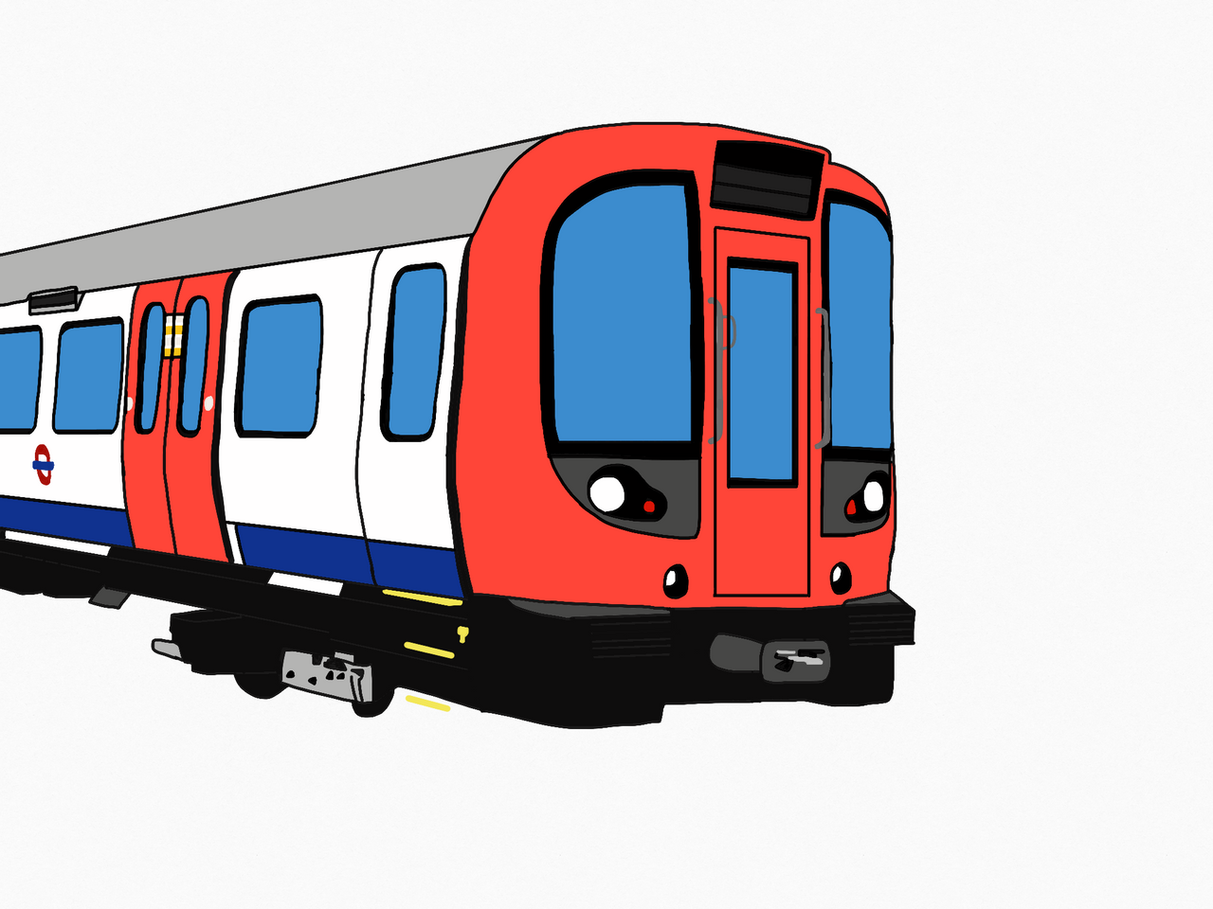
Year 4
This half term, Year 4 had the chance to visit Tate Britain Museum where they got to explore different art work linked with impressionism to help us with our topic in art this half term. They took inspiration from what they saw and sketched some of the art work during their trip and in their art lessons using a range of different mediums.
Miss Alter
Year 4 Class Teacher, Pupil Voice & Sustainability Lead

Year 3
This half-term, Year 3 visited the Natural History Museum. We were there to visit the Earthquakes exhibit and it was very exciting to see what causes earthquakes and how it impacts the environment. We learnt that earthquakes can cause volcanoes and can also cause tsunamis. We even got to experience an earthquake simulation - one that is similar to an earthquake that happened in Japan a few years ago.
Regards
Jonalyn Apresto
Year 3 Team Leader & Acacia Class Teacher

Summer 2 Dates for your Diary!
Upcoming Events
- 5th June Sports Day
- 14th June - Year 4 Viking Workshop
- 3rd- 5th July Year 6 Stubbers Residential
- 9th July Year 6 SATs results day
- 9th July Year 6 Prom 4pm-6pm
- Year 6 performances by class: Spruce 15th July
- Sugar Maple 16th July
- Sweet Gum 17th July
- Friday 12th July- Year 3 Egyptian Day
- 16th July Dojo winners trampoline party

What to do if someone else is collecting your child...
If someone outside of your child’s contact list is collecting your child, please notify us before 12:30pm. We understand that there are emergencies, but if possible, please do not call in the last hour of school (2-3pm) to let us know that someone else will be collecting your child, as this limits the time that we have to convey this to the teacher which could result in your child not being collected immediately at 3:05pm. We do not allow siblings under the age of 14 to collect.

Holidays
The last day of this half term is Friday 24th May at 3.05 pm.
Children will return to school Monday 3rd June at 08.35am .

